Table of contents Page
- Scope 1
- Principles 1
- Wing door units 2
Design types of wing door units, design requirements 4
Hinge bands 5
- Door elements 5
Wing door elements 5
Wing door element TERM 6
Wing door element TELM 7
Wing door element TERE 8
Wing door element TELE 9
Wing door post 11
Wing door slamming post PFARM 10
Wing door slamming post PFARE 12
Wing door slamming post PFALM 13
Wing door slamming post PFALE 14
Wing door hinge post PFSR 15
Wing door hinge post PFSL 16
- Variants of door locks 17
Door lock, mechanical 17
Tubular frame lock RS 18
Striking plate SB 18
Profile cylinder PZ 19
Door latch TDA 19
Door latch TDI 20
Lock spindle VK 20
- Materials 21
- Examples of designation 21

Scope
This company standard specifies the door units and door elements in fence systems according to SN 401-1:2011-08 to be used in the company

Principles
For uniform indication of the dimensions in procurement drawings, the nominal dimensions 1400 and 2200 are used for the height indications of the individual elements.
Unless otherwise specified in other manufacturing documents, the Manufacturing Instructions SN 200 shall be observed for the manufacture of the individual elements.
There are different designs of door elements for door safety category T I and door safety category T II (refer to SN 401-1:2011-08).

Wing door units
Wing door units of door safety categories T I and T II consist of wing door elements, hinge and slamming posts and all other accessories (see tables 1 and 2). They shall always be integrated in the structure as such units with due regard to safety aspects. Wing door units of door safety category T I shall be delivered with the pertaining locks and attachments included in the supply. The lock shall be installed on the site to allow exact adjustment.
Figure 1 shows a wing door unit of safety category T II.

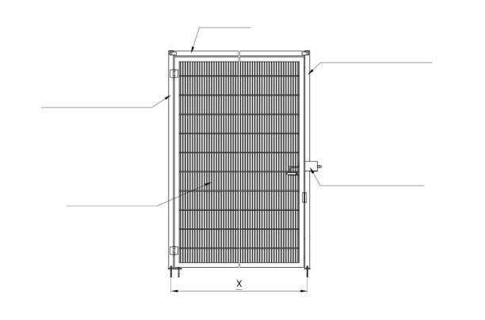
1 door lintel
SN 401-3-FTS
1 door slamming post
SN 401-3-PFALM
1 door hinge post
SN 401-3-PFSL
Electric guard locking
1 wing door element
SN 401-3-TELE
SN 401-4

Fig. 1- Wing door unit of door safety category T II (example: FTLE-2200)

Table 1 – Wing door units of door safety category T I / example FTLM – Single elements
Quantity | Designation | Ordering indication | Material indication for fence system made of  S 235 JR + N a) | Material indication for fence system made of  X5CrNi18-10
1 | Wing door element | SN 401-3 - TELM | S 235 JR + N | X5CrNi18-10 (1.4301)
1 | Door slamming post | SN 401-3 - PFALM | S 235 JR + N | X5CrNi18-10 (1.4301)
1 | Door hinge post | SN 401-3 - PFSL | S 235 JR + N | X5CrNi18-10 (1.4301)
1 | Door lintel b) | SN 401-3 - FTS | S 235 JR + N | X5CrNi18-10 (1.4301)
2 | Hexagon head bolt b) | ISO 4014 – M10x65 | 8.8 A0U | A2-70
2 | Hexagon nut b) | ISO 4032 – M10 | 8 A0U | A2-70
2 | Washer b) | ISO 7089 – 10 | St-HV200 | A2-200

Page 3
SN 401-3:2013-04

Table 1 – Wing door units of door safety category T I / example FTLM – Single elements (continued)
Quantity | Designation | Ordering indication | Material indication for fence system made of  S 235 JR + N a) | Material indication for fence system made of  X5CrNi18-10
4 | Stud anchor | HILTI - HST - M12x115/20 | St GLVZ | -
4 | Stud anchor | HILTI - HST - HCR - M12x115/20 | - | X1NiCrMoCuN25-20-7 (1.4529)
2 | Cover cap | SN 401-2 - AK | PE | PE
1 | Tubular frame lock | SN 401-3 - RSL | X5CrNi18-10 (1.4301) | X5CrNi18-10 (1.4301)
1 | Striking plate (right/left) | SN 401-3 - SB | X5CrNi18-10 (1.4301) | X5CrNi18-10 (1.4301)
1 | Profile cylinder, keyed different | SN 401-3 - PZ | Brass | Brass
1 | Door latch with long lock plate (inside) | SN 401-3 - TDI | X5CrNi18-10 (1.4301) | X5CrNi18-10 (1.4301)
1 | Door latch with long lock plate (outside) | SN 401-3 - TDA | X5CrNi18-10 (1.4301) | X5CrNi18-10 (1.4301)
1 | Lock spindle | SN 401-3 - VK | St A0U | St A0U
3 | Countersunk head screw | DIN EN ISO 10642 - M 5x60 | A2-70 | A2-70
5 | Blind rivet | DIN EN ISO 15978 - 4,8x10-AlA/St-H | St/Al | St/Al
a) Fence system made of S235JR+N (with subsequent powder coating) or S235JR+N TZN
b) Only for wing door units with a nominal height of 2200 mm.

Table 2 – Wing door units of door safety category T II / example FTLE – Single elements
Quantity | Designation | Ordering indication | Material indication for fence system made of  S 235 JR + N a) | Material indication for fence system made of  X5CrNi18-10
1 | Wing door element | SN 401-3 - TELE | S 235 JR + N | X5CrNi18-10 (1.4301)
1 | Door slamming post | SN 401-3 - PFALE | S 235 JR + N | X5CrNi18-10 (1.4301)
1 | Door hinge post | SN 401-3 - PFSL | S 235 JR + N | X5CrNi18-10 (1.4301)
1 | Door lintel b) | SN 401-3 - FTS | S 235 JR + N | X5CrNi18-10 (1.4301)
2 | Hexagon head bolt b) | ISO 4014 – M10x65 | 8.8 A0U | A2-70
2 | Hexagon nut b) | ISO 4032 – M10 | 8 A0U | A2-70
2 | Washer b) | ISO 7089 – 10 | St-HV200 | A2-200
4 | Stud anchors | HILTI - HST - M12x115/20 | St GLVZ | -
4 | Stud anchors | HILTI - HST-HCR - M12x115/20 | - | X1NiCrMoCuN25-20-7 (1.4529)
2 | Cover caps | SN 401-3 - AK | PE | PE
a) Fence system made of S235JR+N (with subsequent powder coating) or S235JR+N TZN
b) Only for wing door units with a nominal height of 2200 mm.

Design types of wing doors, design requirements
Wing door units as defined in this standard are available in two design types (see figures 2, 3 and table 3).
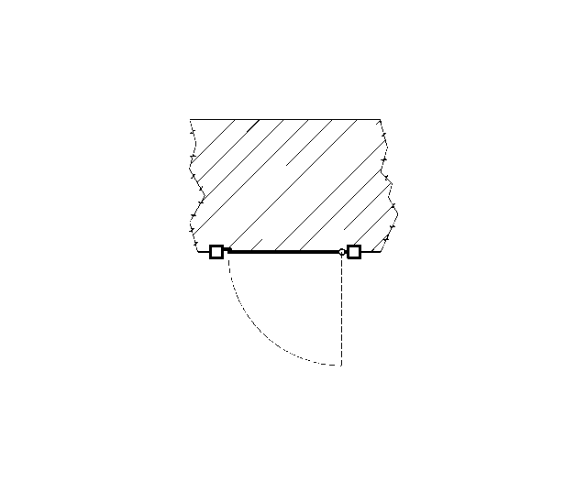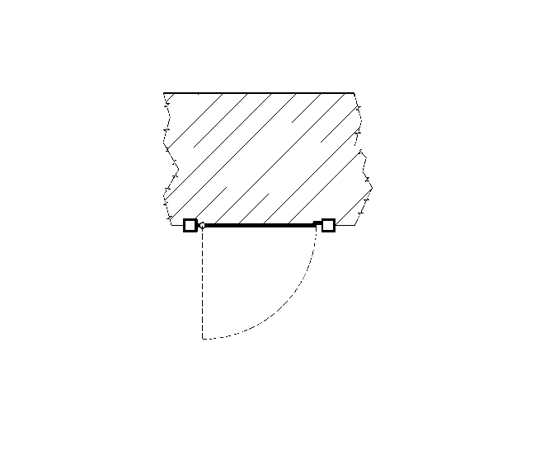For reasons of safety aspects, only such doors may be used in a protective fence system which open in the direction away from the danger zone (escape doors).

Fig. 3 – Wing door unit FTL
(hinged on the left, opening to the outside)
Danger zone

Fig. 2 – Wing door unit FTR
(hinged on the right, opening to the outside)

Fence systems shall be designed in compliance with the following requirements:
- The wing door unit shall be without any connection to the surrounding fence system.
- Fence nettings shall never be fastened direct to a door post, but only to a separate fence post.
- Door units shall not be installed at the very corner of a fencing as this makes it impossible to comply with the specified gap dimensions. There shall be at least one fence netting between a fence corner and the door unit.
- To prevent any foreseeable bypassing of the protective fence system, door units in front of staircases shall be provided with additional lateral fence elements (see Fig. 4).
- Posts installed near each other shall be positioned in such a way that the distances between the foot plates (welding item 002 in figures 12 to 17) do not exceed 10 mm.

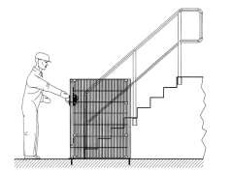Example of lateral protection with additional fence element.
Without additional fence element the safety door can be bypassed as the guard rail of the stairway does not prevent access to the danger zone.

Fig. 4 – Additional lateral fence element

Table 3 – Wing door units – Design types

Ordering indication | Door safety category | Nominal height | Clear opening width  B | Drillhole distance X a) | Weight kg/unit | Opening direction
SN 401-3 - FTRM | T I | 1400 | 950 | 1020 | 54,15 | right
SN 401-3 - FTRM | T I | 1400 | 1350 | 1420 | 58,58 | right
SN 401-3 - FTRM | T I | 2200 | 950 | 1020 | 81,57 | right
SN 401-3 - FTRM | T I | 2200 | 1350 | 1420 | 93,05 | right
SN 401-3 - FTLM | T I | 1400 | 950 | 1020 | 54,15 | left
SN 401-3 - FTLM | T I | 1400 | 1350 | 1420 | 58,58 | left
SN 401-3 - FTLM | T I | 2200 | 950 | 1020 | 76,12 | left
SN 401-3 - FTLM | T I | 2200 | 1350 | 1420 | 85,42 | left
SN 401-3 - FTRE | T II | 1400 | 950 | 1020 | 51,05 | right
SN 401-3 - FTRE | T II | 1400 | 1350 | 1420 | 56,58 | right
SN 401-3 - FTRE | T II | 2200 | 950 | 1020 | 78,47 | right
SN 401-3 - FTRE | T II | 2200 | 1350 | 1420 | 89,95 | right
SN 401-3 - FTLE | T II | 1400 | 950 | 1020 | 51,05 | left
SN 401-3 - FTLE | T II | 1400 | 1350 | 1420 | 56,58 | left
SN 401-3 - FTLE | T II | 2200 | 950 | 1020 | 78,47 | left
SN 401-3 - FTLE | T II | 2200 | 1350 | 1420 | 89,95 | left
a) see dimension X in figure 1.

Hinge bands

The wing door elements and the hinge posts shall be levelled and aligned together by the supplier for the welding on of the hinge bands. The inner half, J (see Fig. 5), shall be welded up with the door element, the outer half, A, with the hinge post. After this, the surface treatment can be carried out. If door element and posts are shipped separately afterwards, the parts belonging together shall be unmistakably match-marked by the supplier. Table 4 shows the dimensions of the hinge band.

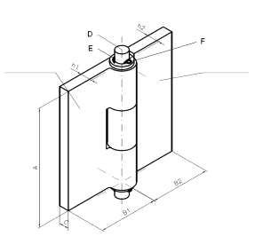Hinge band SN-401-3-GB
Outer half A
Inner half J
(developed from DIN 31211; has been withdrawn)

Table 4 – Dimensions
A | 80 mm
B1 | 40 mm
B2 | 40 mm
C | 7 mm
h1 | 8 mm
h2 | 8 mm
D | Clevis pin DIN EN 22340-8x90
E | Washer DIN EN ISO 7089
F | Split pin DIN EN ISO 1234- 2x15

Hinge bands and their connecting parts shall be ordered to suit the material selected for the fence and door elements.

Fig. 5 - Hinge band GB

Door elements
Door element is the general term for all individual elements used to make up wing door units and their posts (see Fig. 1).

Wing door elements

Depending on their use for door units of door safety category T I or T II, wing door elements shall be ordered in different design types. The types TERM and TELM are provided with preparation for the installation of a mechanical lock, the types TERE and TELE have no such preparation. Table 5 states the dimensions of the wing door elements. Figures 6 to 9 show the elements of wing doors.

Table 5 – Wing door elements
Ordering indication | Door safety category | Height H | Clear opening width  B | Weight kg/unit | Opening direction
SN 401-3 - TERM | T I | 1400 | 950 | 31,90 | right
SN 401-3 - TERM | T I | 1400 | 1350 | 39,43 | right
SN 401-3 - TERM | T I | 2200 | 950 | 44,85 | right
SN 401-3 - TERM | T I | 2200 | 1350 | 54,15 | right
SN 401-3 - TELM | T I | 1400 | 950 | 31,90 | left
SN 401-3 - TELM | T I | 1400 | 1350 | 39,43 | left
SN 401-3 - TELM | T I | 2200 | 950 | 44,85 | left
SN 401-3 - TELM | T I | 2200 | 1350 | 54,15 | left
SN 401-3 - TERE | T II | 1400 | 950 | 35,66 | right
SN 401-3 - TERE | T II | 1400 | 1350 | 43,19 | right
SN 401-3 - TERE | T II | 2200 | 950 | 50,69 | right
SN 401-3 - TERE | T II | 2200 | 1350 | 59,99 | right
SN 401-3 - TELE | T II | 1400 | 950 | 35,66 | left
SN 401-3 - TELE | T II | 1400 | 1350 | 43,19 | left
SN 401-3 - TELE | T II | 2200 | 950 | 50,69 | left
SN 401-3 - TELE | T II | 2200 | 1350 | 59,99 | left

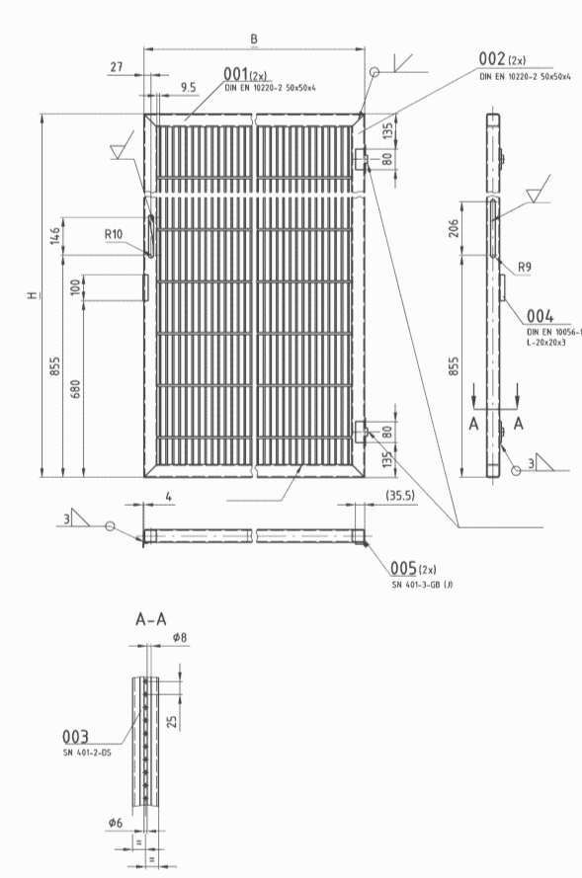Wind door element TERM

tack- welded

welded together with post PFSL

Fig. 6 – Wing door element TERM

Wing door element TELM

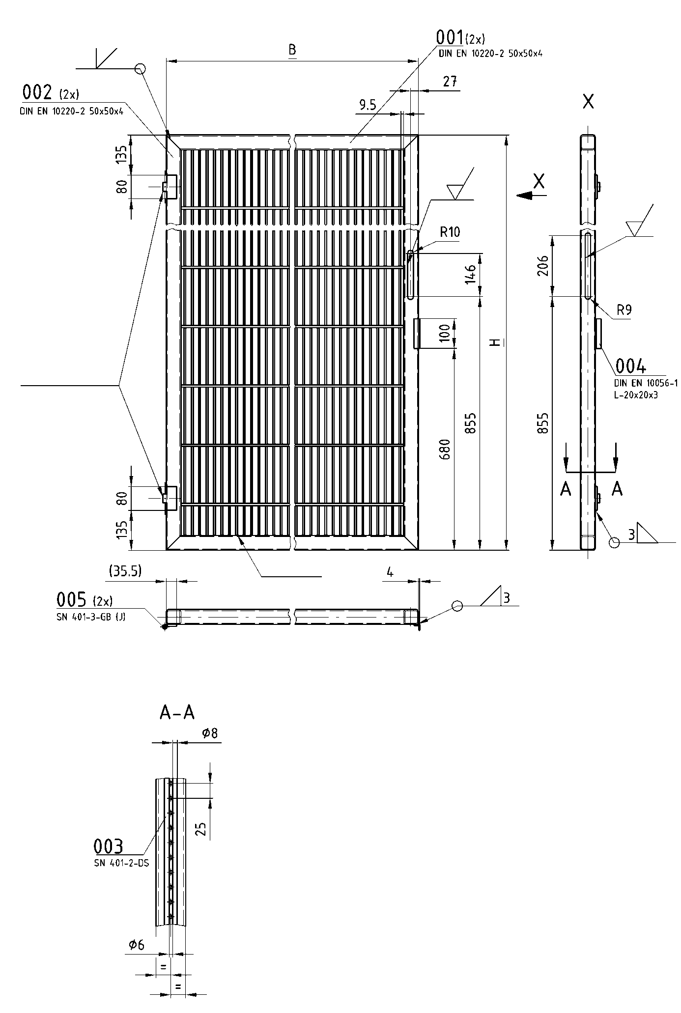Welded together with post PFSL

tack-welded

Fig. 7 – Wing door element TELM

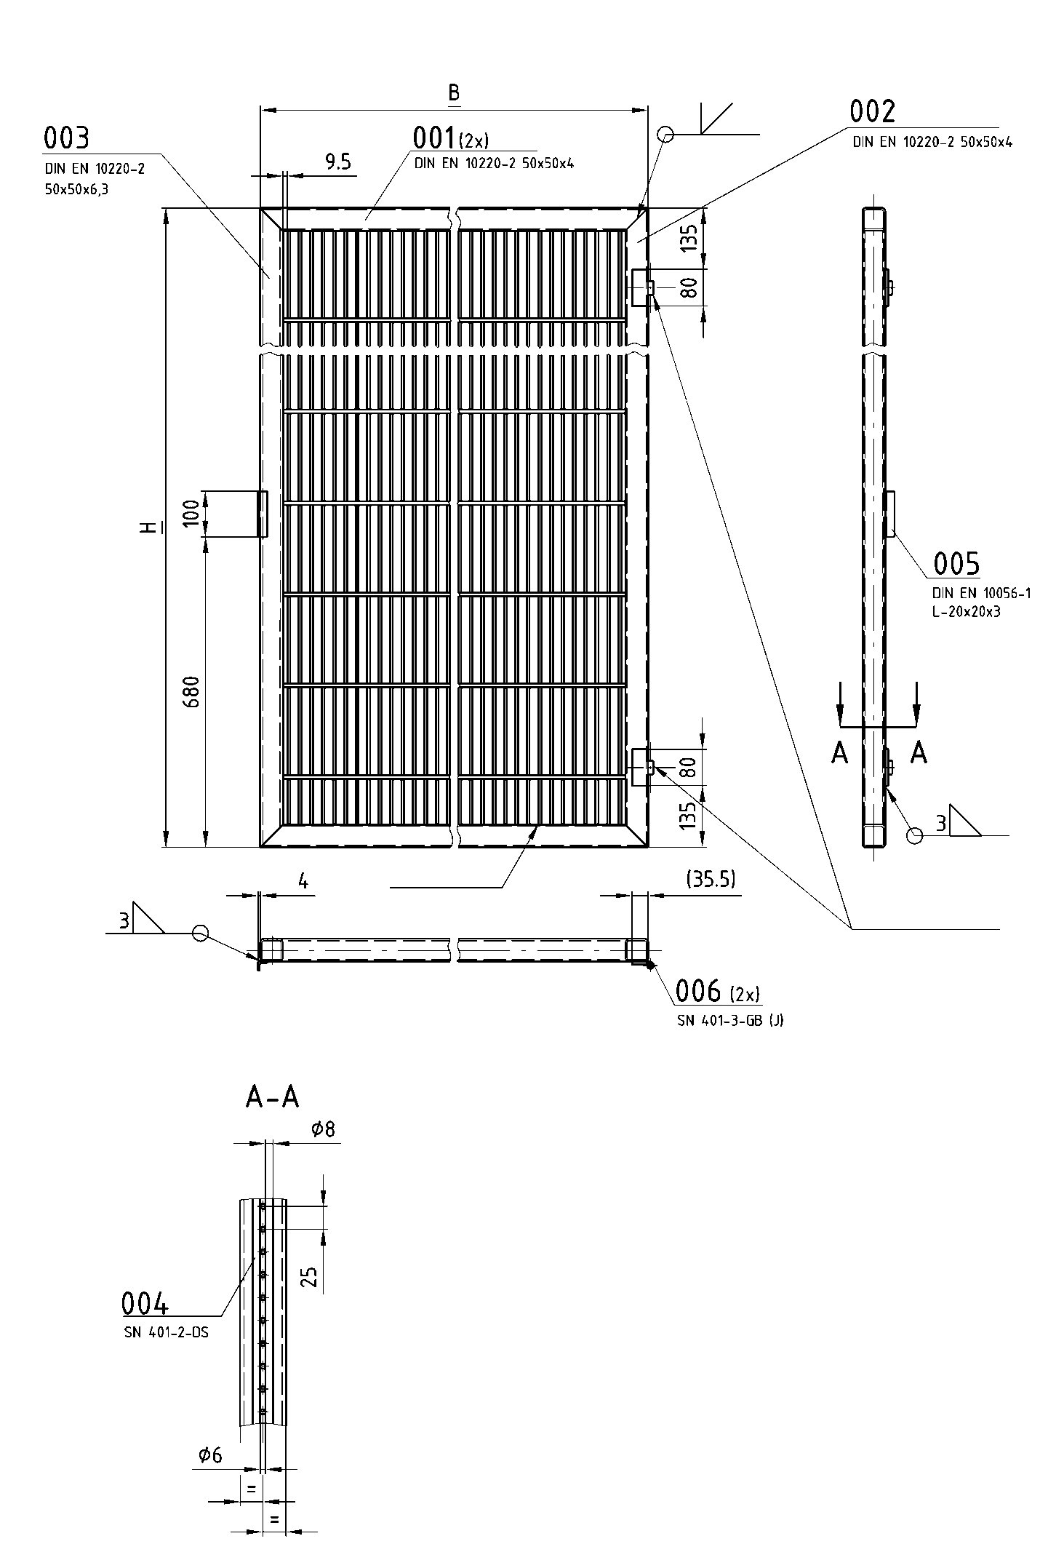
Wing door element TERE

tack-
welded Welded together
with post PFSR

Fig. 8 – Wing door element TERE

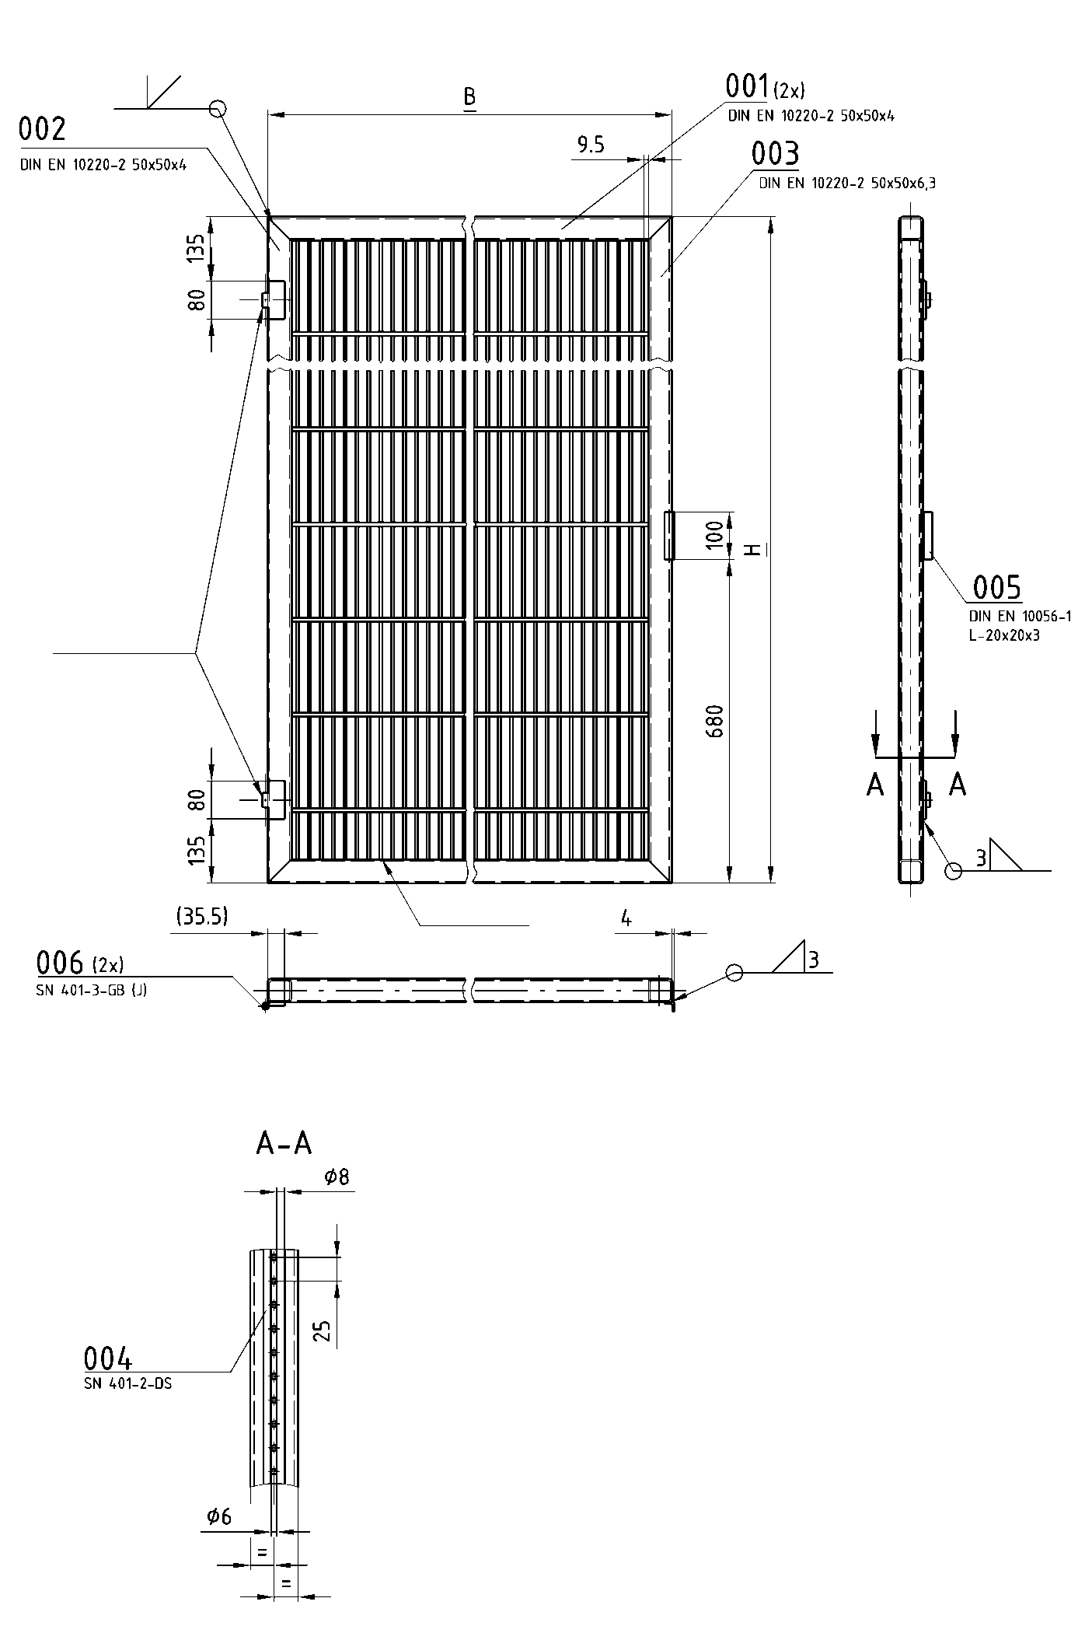
Wing door element TELE

Welded together with post PFSL

tack- welded

Fig. 9 – Wing door element TELE

Wing door post

To avoid unintentional locking in of persons in the danger zone, an angle section with oblong hole shall be provided on the slamming post of the wing door for the use of a personal padlock (Figs. 10 and 11). This personal padlock is intended to show that one or more persons are still staying in the danger zone. In addition, the padlock prevents the closing of the door.
The slamming posts and hinge posts are listed in Table 6 and illustrated in the figures 12 to 17.

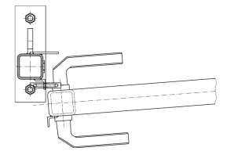
Fig. 10 – Device for personal padlock with door open

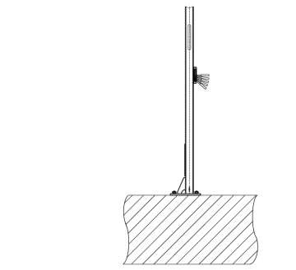
Angle-section with attached personal
padlocks.

Fig. 11 – Device for personal padlock at slamming post Table 6 – Wing door posts
Ordering indication | Function | Door safety category | Height H | Weight kg/unit | Opening direction
SN 401-3-PFARM-1400 | Slamming- post | T I | 1410 | 9,35 | right
SN 401-3-PFARM-2200 | Slamming- post | T I | 2270 | 14,24 | right
SN 401-3-PFARE-1400 | Slamming- post | T II | 1410 | 12,99 | right
SN 401-3-PFARE-2200 | Slamming- post | T II | 2270 | 19,96 | right
SN 401-3-PFALM-1400 | Slamming- post | T I | 1410 | 9,35 | left
SN 401-3-PFALM-2200 | Slamming- post | T I | 2270 | 14,24 | left
SN 401-3-PFALE-1400 | Slamming- post | T II | 1410 | 12,99 | left
SN 401-3-PFALE-2200 | Slamming- post | T II | 2270 | 19,96 | left
SN 401-3-PFSR-1400 | Hinge post | T I + T II | 1410 | 10,13 | right
SN 401-3-PFSR-2200 | Hinge post | T I + T II | 2270 | 15,03 | right
SN 401-3-PFSL-1400 | Hinge post | T I + T II | 1410 | 10,13 | left
SN 401-3-PFSL-2200 | Hinge post | T I + T II | 2270 | 15,03 | left

Wing door slamming post PFARM

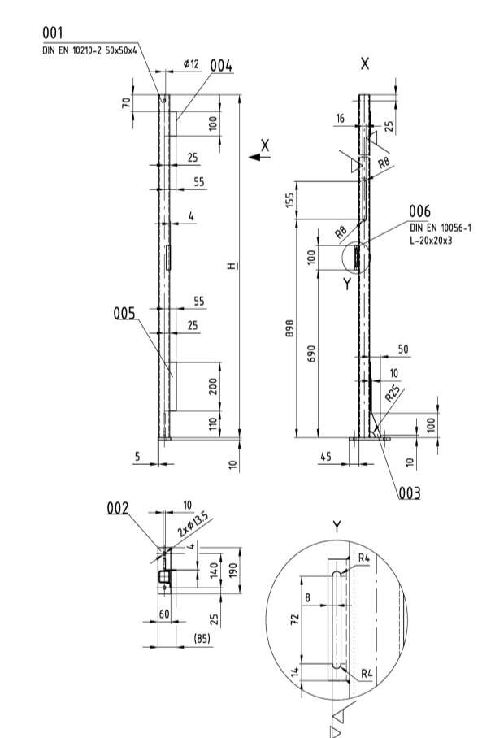

Fig. 12 – Wing door slamming post PFARM

Wing door slamming post PFARE

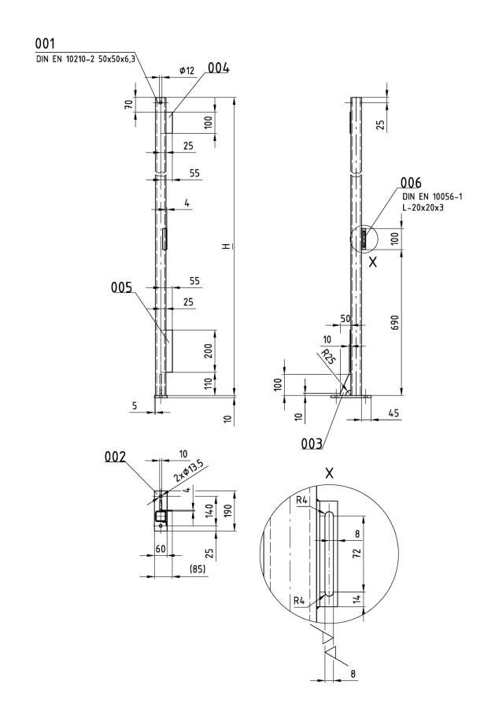

Fig. 13 – Wing door slamming post PFARE

Wing door slamming post PFALM

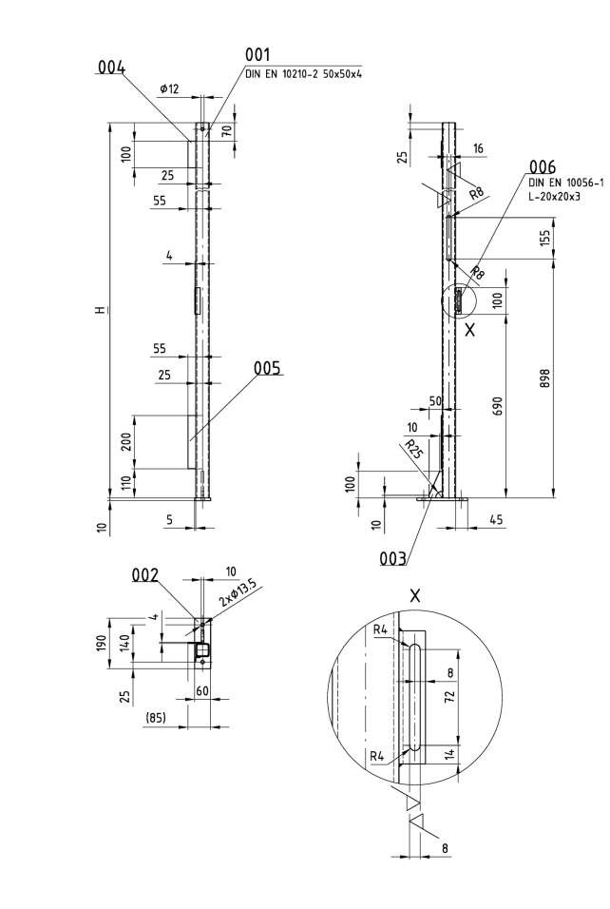
Fig. 14 – Wing door slamming post PFALM

Wing door slamming post PFALE

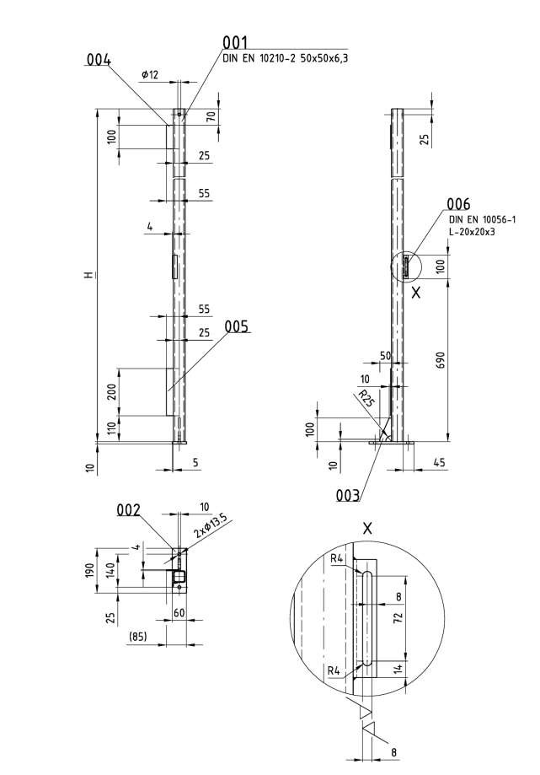

Fig. 15 – Wing door slamming post PFALE

Wing door hinge post PFSR

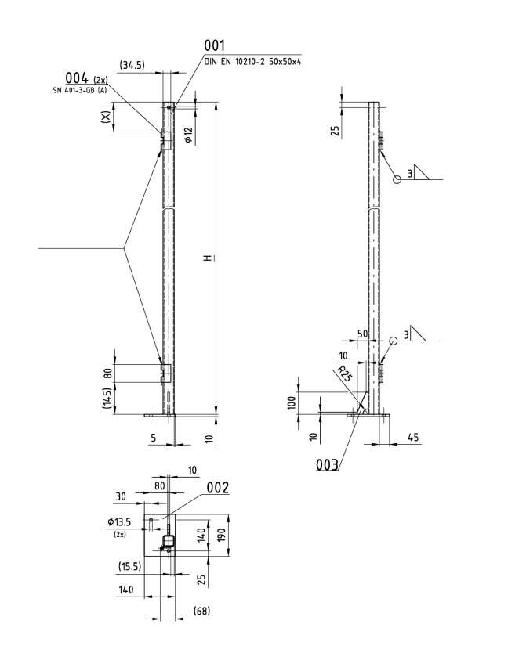welded together with door element TER

Fig. 16 – Wing door hinge post PFSR

Wing door hinge post PFSR

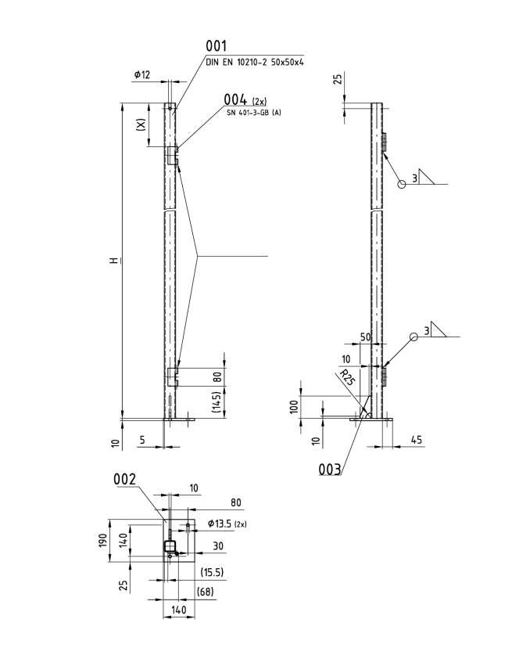Welded together with door element TEL

Fig. 17 – Wing door hinge post PFSL

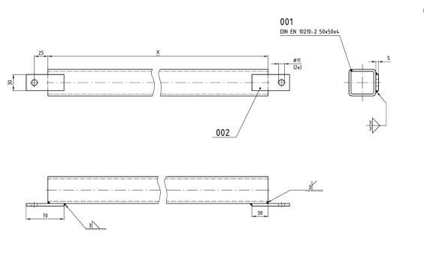
Fig. 18 – Door lintel FTS Table 7 – Door lintels
Ordering indication | Door safety category | Clear opening width B | Length X | Weight kg/unit | Opening direction
SN 401-3 – FTS-950 | T I + T II | 950 | 970 | 5,46 | right and left
SN 401-3 – FTS-1350 | T I + T II | 1350 | 1370 | 7,64 | right and left

Variants of door locks
In fence systems of door safety category T I, all door units stated in this standard are provided with the appropriate tubular frame lock and accessories. The individual elements are shown in Table 7.
For doors of door safety category T II, an appropriate door lock shall be determined in accordance with the requirements and the type of door lock variant shall be specified in addition to the door unit. The electric components required for door safety category T II are specified in SN 401-4.:2010-03.
The safety devices required in the respective door safety category shall be applied at all door units of a danger zone.

Door lock, mechanical

The mechanical locking of door units according to this SN 401-3 makes it necessary to use door elements of the types TERM or TELM, the types TERE and TELE are not provided with preparation for the installation of mechanical locks (electric guard locking or key transfer system).
The door locks shall be installed on the customer's site to ensure exact adjustment.
The tubular frame lock and the striking plate are fastened to the door and the door post with open end blind rivets with countersunk head according to DIN EN ISO 15978.
Mechanical door locks shall be keyed different, i.e. every lock shall have its own key. Every locking cylinder shall be supplied by the manufacturer with at least two keys.
The individual elements are illustrated in figures 19 to 24.

Tubular frame lock RS

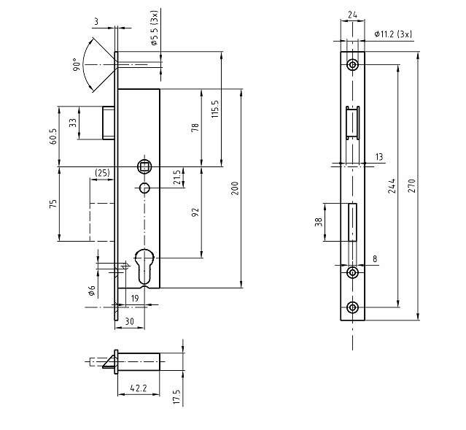

Fig. 19 – Tubular frame lock RSR (example: right hinged)

Striking plate SB

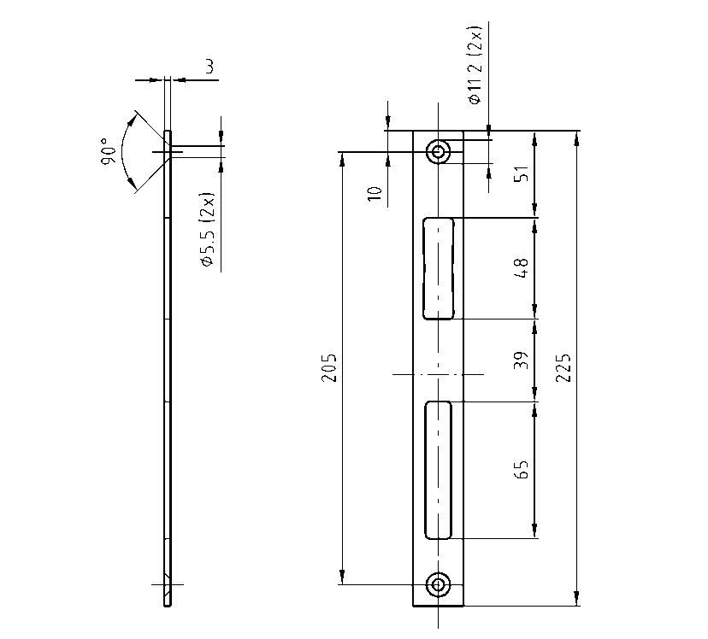

Fig. 20 – Striking plate SB

Profile cylinder PZ

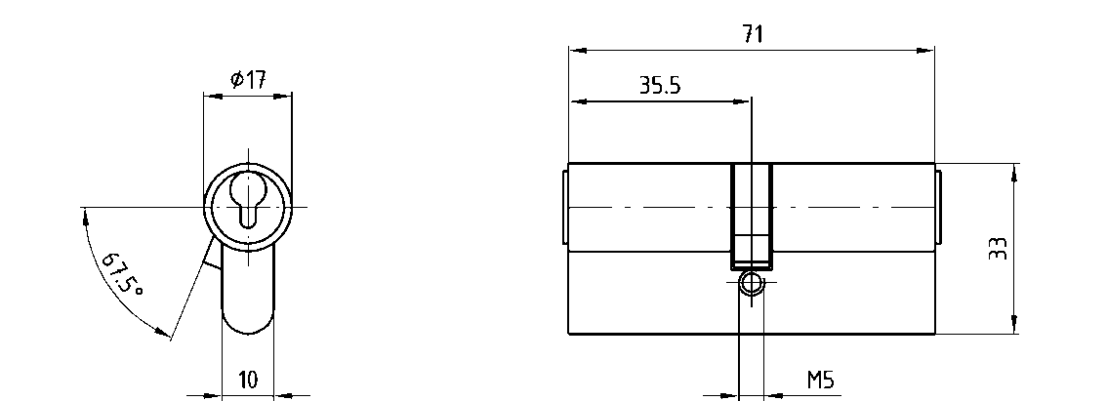

Fig. 21 – Profile cylinder PZ

Door latch TDA

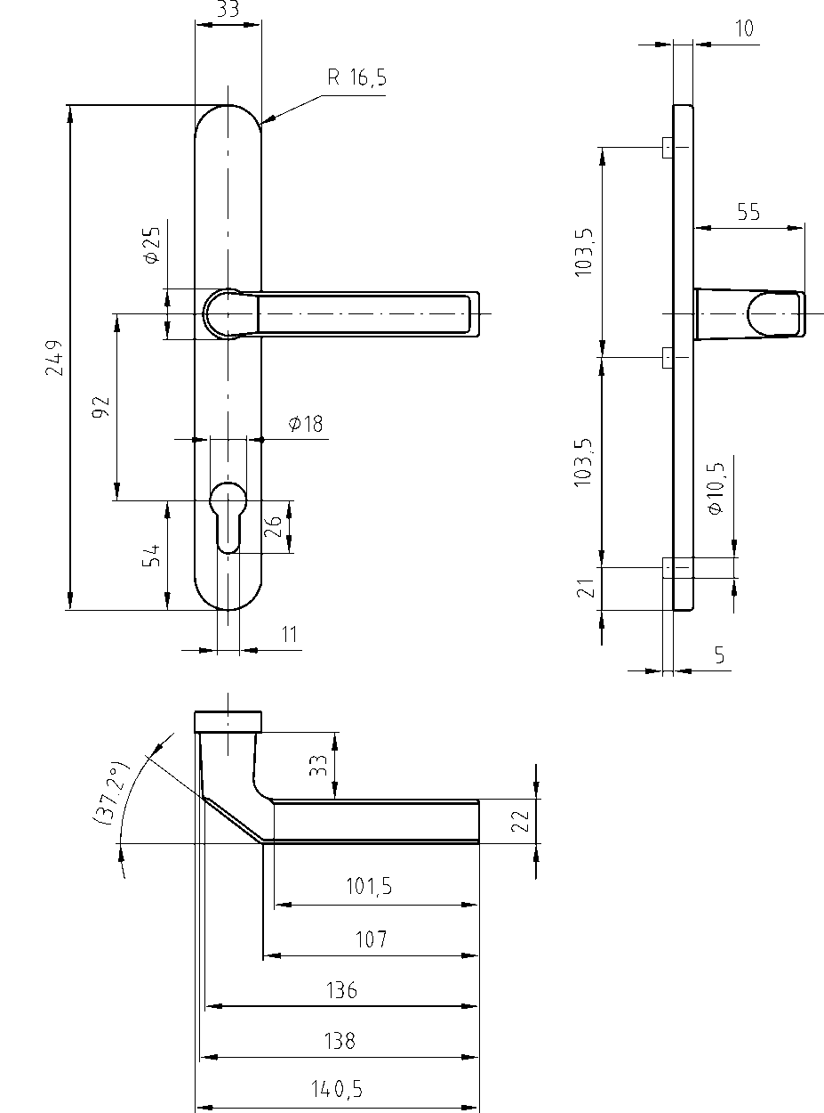

Fig. 22 – Door latch TDA

Door latch TDI

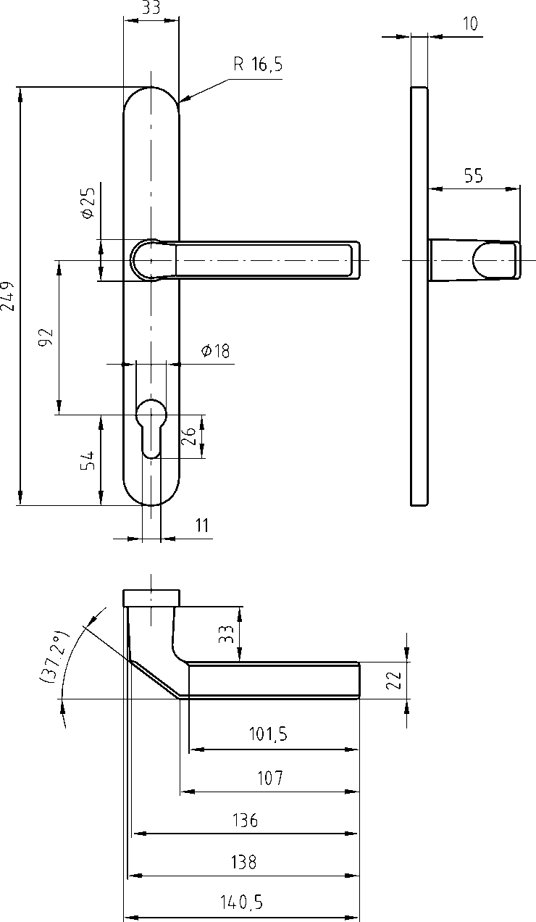

Fig. 23 – Door latch TDI

Lock spindle VK
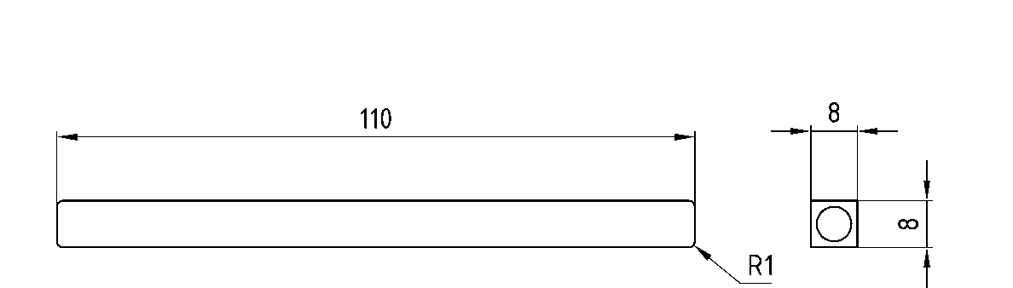

Fig. 24 – Lock spindle VK

Materials
A2-70 according to DIN EN ISO 3506-1
A2-200 according to DIN EN ISO 3506-1
Brass brass, general, non-specific
PE according to DIN EN ISO 1043-1, polyethylene
S235JR according to DIN EN 10025-2:2005-04, structural steel, surface untreated (for subsequent powder coating)
S235JR TZN according to DIN EN 10025-2:2005-04, structural steel, surface galvanised
St/Al steel/aluminium
ST GLVZ steel, electrogalvanised
ST A0U steel, surface galvanised
X1NiCrMoCuN25-20-7 (1.4529) according to DIN EN 10028-7:2008-02, austenitic stainless steel, without
surface treatment
X5CrNi18-10 (1.4301) according to DIN EN 10088-3:2005-09, austenitic stainless steel, without
surface treatment

Examples of designation
Designation of a wing door unit of nominal height 1400 mm, 950 mm clear opening width, left hinged, door safety category T II, made of galvanised structural steel:
Wing door unit SN 401-3-FTLE-1400x950-S235JR-TZN

Designation of a door hinge post of 2200 mm nominal height, for right hinged doors, made of X5CrNi18-10 (1.4301):
Door hinge post SN 401-3-PFSR-2200-X5CrNi18-10

Designation of a door lock profile cylinder:
Door lock profile cylinder SN 401-3-PZ

Referenced technical standards, codes and regulations

DIN 31211 (withdrawn) Hinges; Assemblies of parts
DIN EN 3506-1 Mechanical properties of corrosion-resistant stainless steel fasteners - Part 1: Bolts, screws and studs
DIN EN 10025-2:2005-04 Hot rolled products of structural steels - Part 2: General technical delivery conditions for non-alloy structural steels
DIN EN 10028-7:2008-02 Flat products made of steels for pressure purposes - Part 7: Stainless steels DIN EN 10056-1 Structural steel equal and unequal leg angles - Part 1: Dimensions
DIN EN 10088-3:2005-09 Stainless steels - Part 3: Technical delivery conditions for semi-finished products, bars, rods, wire, sections and bright products of corrosion resisting steels for general purposes
DIN EN 10210-2 Hot finished structural hollow sections of non-alloy and fine grain steels - Part 2: Tolerances, dimensions and sectional properties
DIN EN 22340 Clevis pins without head
DIN EN ISO 1043-1 Plastics - Symbols and abbreviated terms - Part 1: Basic polymers and their special characteristics DIN EN ISO 1234 Split pins
DIN EN ISO 7089 Plain washers - Normal series, product grade A DIN EN ISO 10642 Hexagon socket countersunk head screws
DIN EN ISO 15978 Open end blind rivets with break pull mandrel and countersunk head – AIA/St

SN 200 Manufacturing instructions
SN 401-1:2011-08 Safety provisions for danger zones; Fence systems; Overview - Definitions
SN 401-4:2010-03 Safety provisions for danger zones; Electric door interlocking - Design directive

